LINK VERCEL (<https://uts-mi-5-a-heriyanto.vercel.app/>)

1. Get(local)

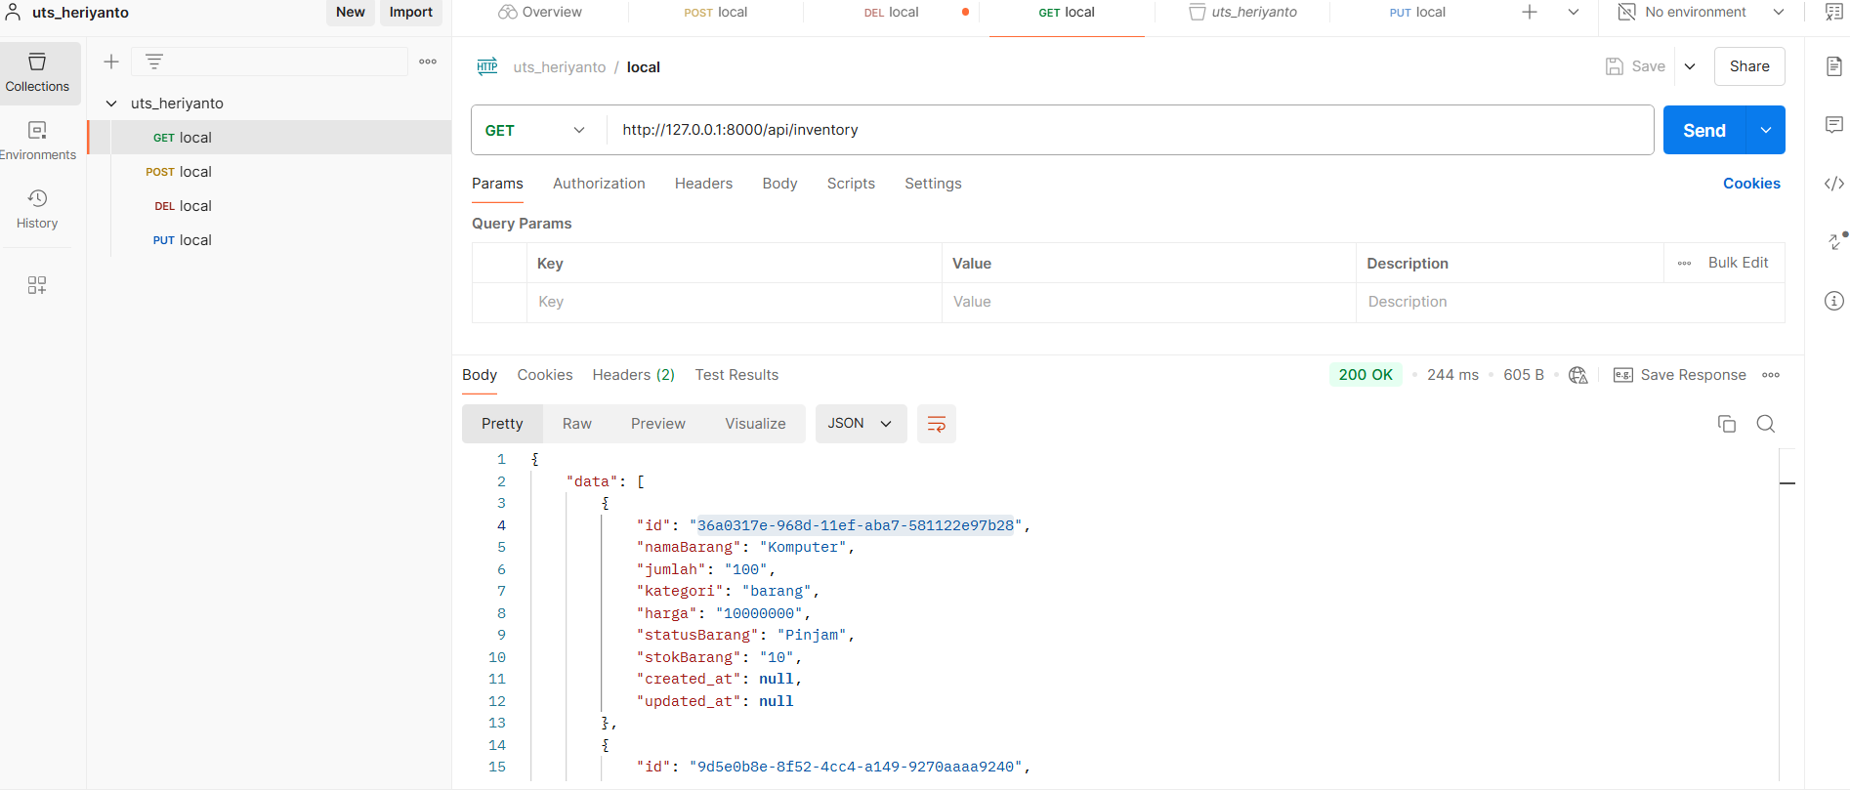

1. Post(local)

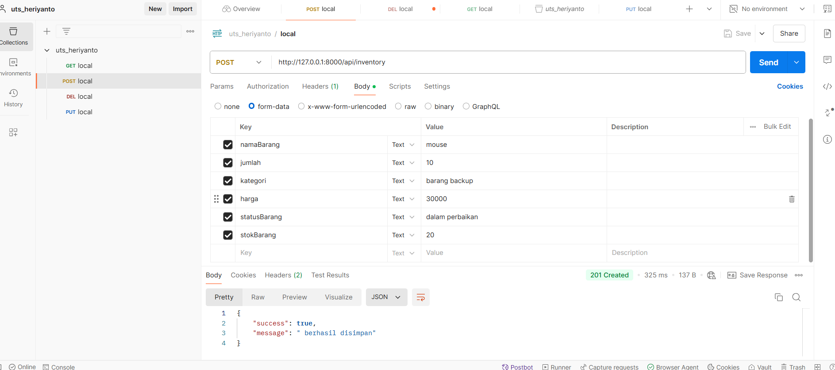

1. Delete(local)

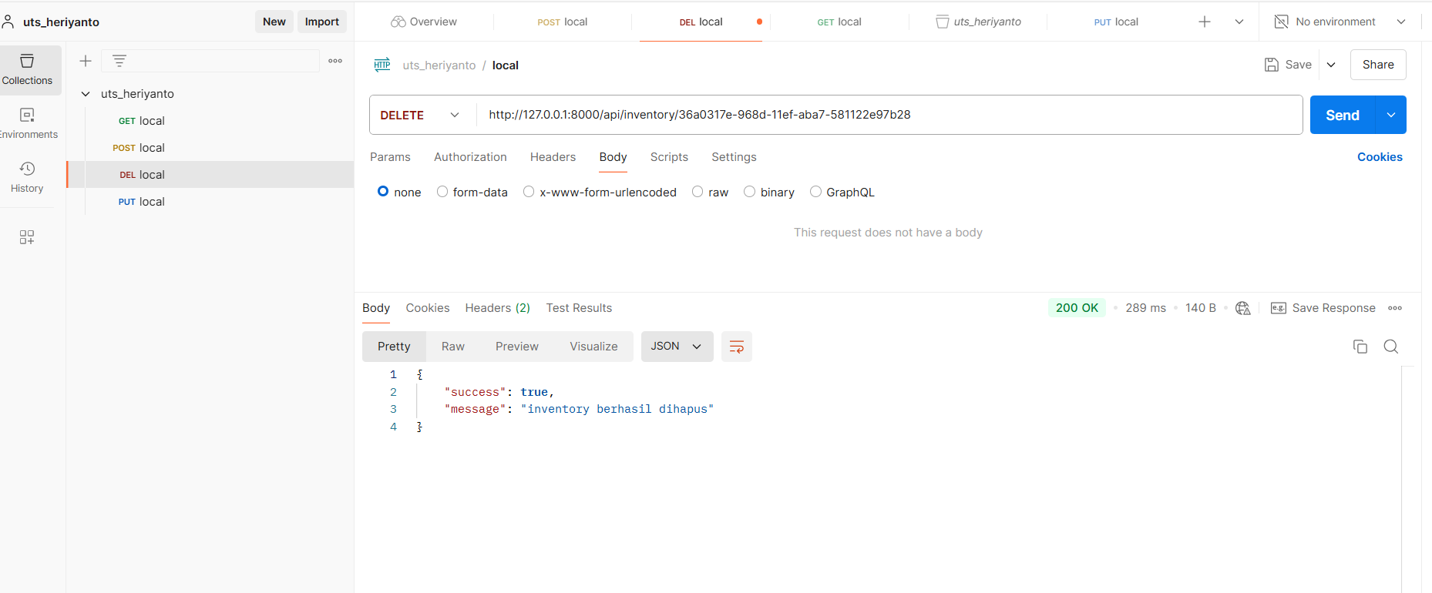

1. Put(local) gagal

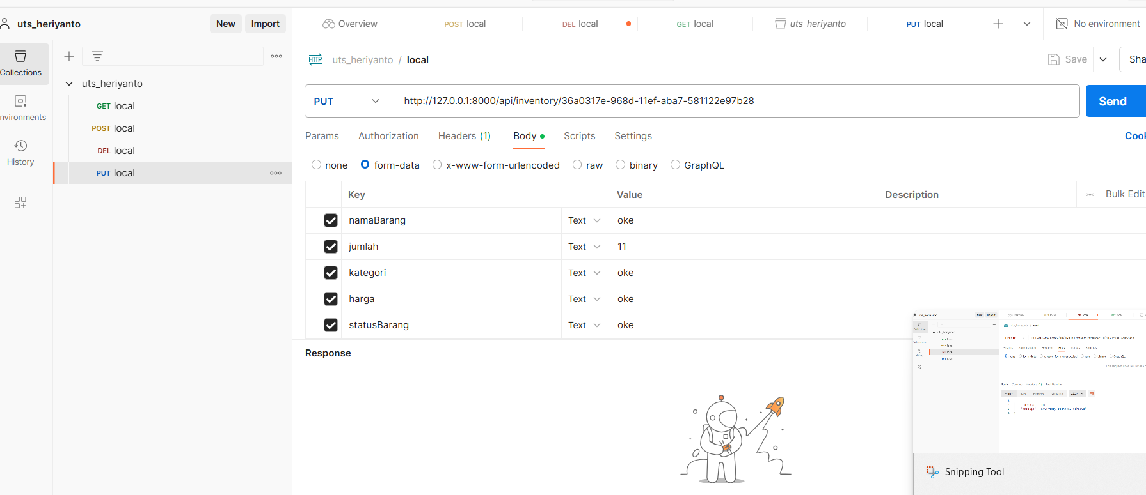

1. Get (vercel)

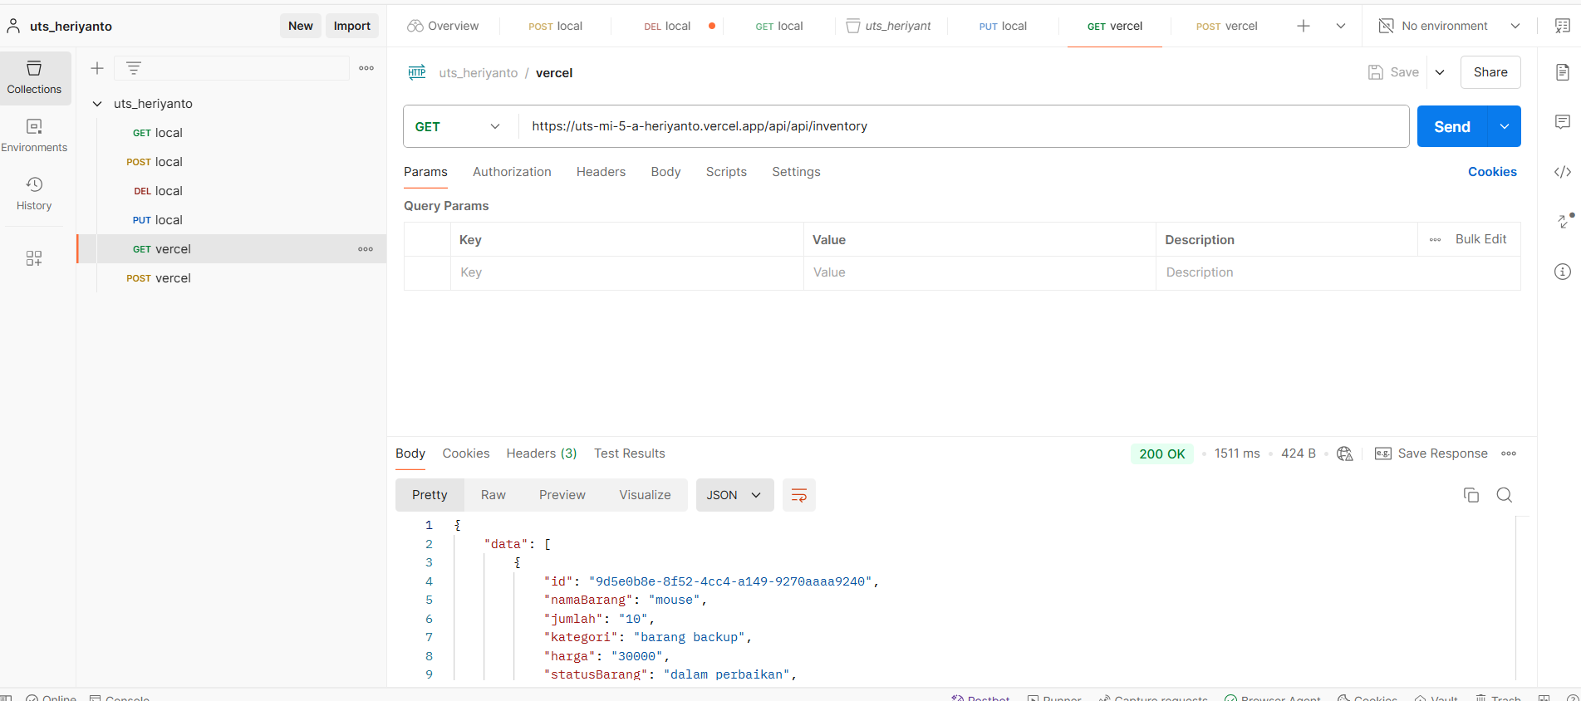

1. Post (vercel)

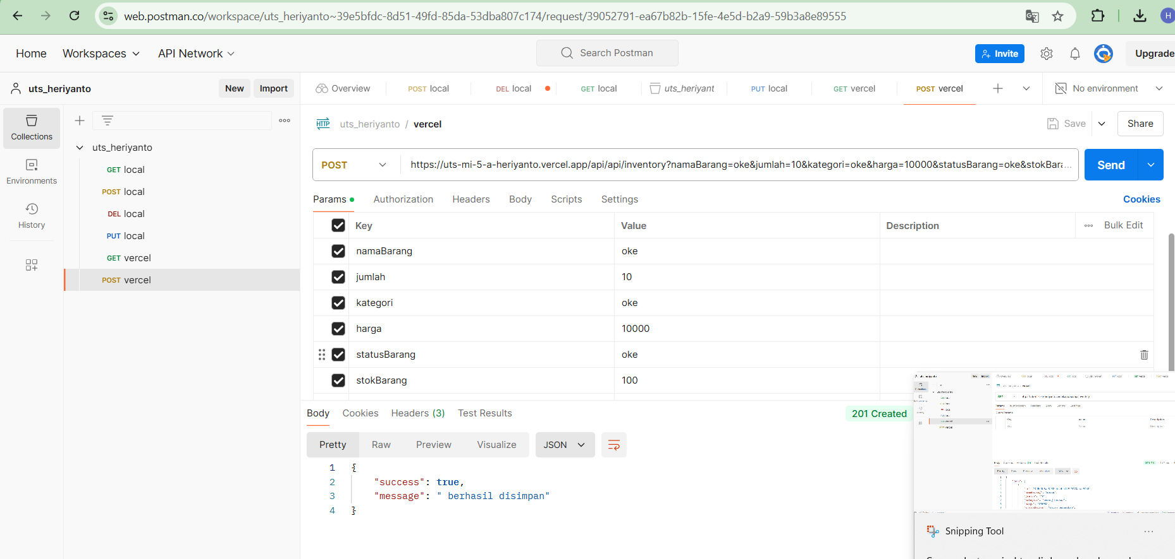

1. Delete(vercel)

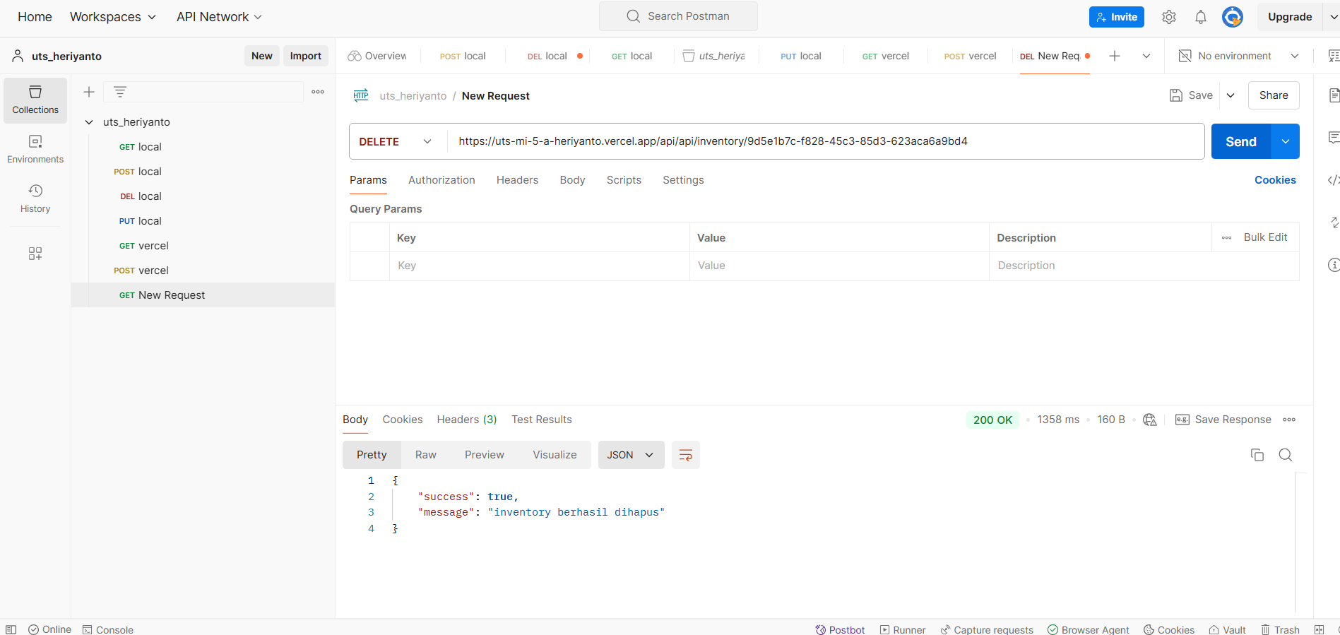

1. Put (vercel) gagal sama seperti local